Project Planning Phase
Project Planning Template (Product Backlog, Sprint Planning, Stories, Story points)

Date
Team ID
Project Name
Maximum Marks
Product Backlog, Sprint Schedule, and Estimation (4 Marks)
Use the below template to create product backlog and sprint schedule
Sprint | Functional Requirement (Epic) | User Story Number | User Story / Task | Story Points | Priority | Team Members
Sprint-1 | Data Collection | USN-1 | As a data analyst, I can collect sales, product, and customer datasets for analysis. | 3 | High | 1
Sprint-1 | Data Cleaning | USN-2 | As a data analyst, I can clean and preprocess the dataset by removing duplicates and handling missing values | 3 | High | 3
Sprint-2 | Sales Analysis | USN-3 | As a business analyst, I can analyze sales trends to identify high-performing products. | 4 | High | 2
Sprint-2 | Customer Behavior Analysis | USN-4 | As a business analyst, I can study customer purchasing patterns to understand buying behavior. | 4 | High | 3
Sprint-3 | Product Placement Analysis | USN-5 | As a business analyst, I can identify the best product placement strategy using sales and customer insights. | 5 | High | 3
Sprint-3 | Dashboard Development | USN-6 | As a Tableau developer, I can build an interactive dashboard to visualize KPIs and business insights. | 3 | Medium | 1
Sprint-4 | Business Recommendations | USN-7 | As a business manager, I can generate recommendations to improve product placement and profitability. | 2 | Medium | 2
Sprint-4 | Testing & Validation | USN-8 | As a tester, I can validate dashboard accuracy and verify analytical results. | 2 | Medium | 1

Project Tracker, Velocity & Burndown Chart: (4 Marks)
Sprint | Total Story Points | Duration | Sprint Start Date | Sprint End Date (Planned) | Story Points Completed (as on Planned End Date) | Sprint Release Date (Actual)
Sprint-1 | 20 | 6 Days | 2 Jul 2026 | 3 Jul 2026 | 20 | 15 Jul 2026
Sprint-2 | 20 | 6 Days | 6 Jul 2026 | 7 Jul 2026
Sprint-3 | 20 | 6 Days | 10Jul 2026 | 12 Jul 2026
Sprint-4 | 20 | 6 Days | 13Jul 2026 | 14 Jul 2026

Velocity:
Imagine we have a 10-day sprint duration, and the velocity of the team is 20 (points per sprint). Let’s calculate the team’s average velocity (AV) per iteration unit (story points per day)

Average Velocity (AV)
$$\boxed{\text{Average Velocity}=\frac{\text{Total Story Points}}{\text{Sprint Duration (Days)}}}$$ Calculation:
$$\boxed{\text{Average Velocity}=\frac{20}{10}=2\text{ Story Points/Day}}$$Burndown Chart:
A burn down chart is a graphical representation of work left to do versus time. It is often used in agile software development methodologies such as Scrum. However, burn down charts can be applied to any project containing measurable progress over time.

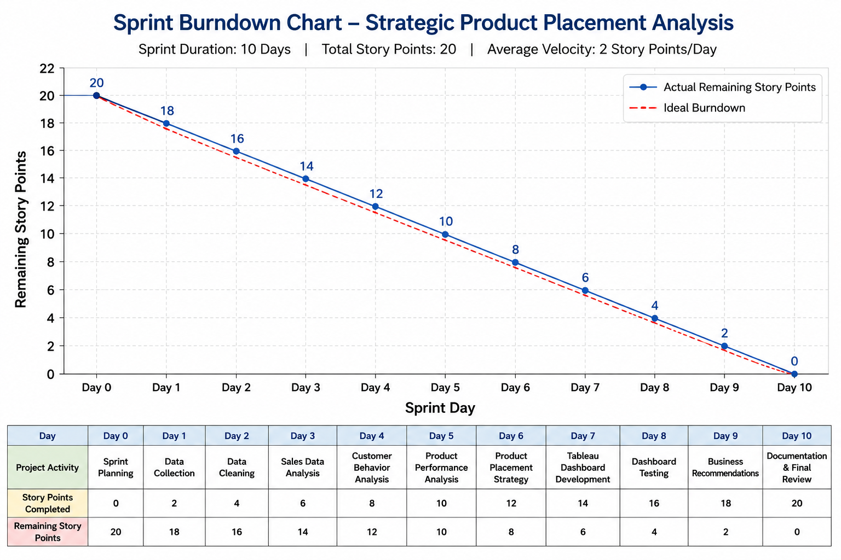
https://www.visual-paradigm.com/scrum/scrum-burndown-chart/
https://www.atlassian.com/agile/tutorials/burndown-charts

Reference:
https://www.atlassian.com/agile/project-management
https://www.atlassian.com/agile/tutorials/how-to-do-scrum-with-jira-software
https://www.atlassian.com/agile/tutorials/epics
https://www.atlassian.com/agile/tutorials/sprints
https://www.atlassian.com/agile/project-management/estimation
https://www.atlassian.com/agile/tutorials/burndown-charts

